
Kura-Kyowa Kirin 4Q 2025 Earnings; Highlighted Komzifti Launch Momentum and 2026 Clinical catalysts across KOMET-007/-008

Company: Kura-Kyowa Kirin  Drug: Ziftomenib (Menin-MLLi), Kyowa Kirin / KK2845 (TIM-3 ADC) | Date: Feb 9, 2026; Mar 05, 2026  Source(s): Webcast, Press Release, 10-K Form, 8-K Form, Presentation (Kura); Presentation, Consolidated Financial Summary, Appendix to the Consolidated Financial Summary, 'Vision 2030 and Beyond' Presentation, Transcript (Kyowa Kirin)
What happened:
- Kura and Kyowa Kirin released its 4Q and Full-Year 2025 earnings providing updates on the ziftomenib development program, along with launch trajectory post FDA approval in R/R NPM1m AML (Nov 13, 2025) and further clinical development plans/updates
- Company reported $2.1M in Komzifti net revenue during the initial five-week post-approval window. Launch momentum is supported by rapid payer uptake, with ~84% of private payers aligning coverage to label within 90 days
- The company provided updates on its ziftomenib AML development program, reiterating key expected milestones
- During Q&A, management noted that step editing is "uncommon in oncology" and represents independent validation of Komzifti profile, while reiterating that "leadership in R/R NPM1m AML will be determined by preference, not by who enters the market first"

Key Approval Timelines:
 | US | EU
R/R NPM1m AML  (Ph 1/2 KOMET-001; ziftomenib) | Approved  (Nov 13, 2025) | NA  (CI primary intel at ASCO/EHA 2025 indicated EU submission is unlikely based on single arm study; no changes to timelines)
1L NPM1m or KMT2Ar unfit AML  (Ph 3 KOMET-017-NIC; ziftomenib + Ven + Aza) | 3Q 2028  (CI assumptions based on 2028 data readout; no changes to timelines) | 1Q 2033  (CI assumptions based on Nov 2031 PCD; no changes to timelines)
1L NPM1m or KMT2Ar fit AML  (Ph 3 KOMET-017-IC; ziftomenib + 7+3) | 3Q 2028  (CI assumptions based on 2028 data readout; no changes to timelines) | 1Q 2033  (CI assumptions based on Nov 2031 PCD; no changes to timelines)

Impact (CI PoV): MEDIUM
- Kura reaffirmed expansion into 1L AML across fit and unfit populations; however, the potential of the Ven-based triplet in 1L unfit AML may not be fully maximized due to the abbreviated 21-day dosing schedule
- Despite being second to market menin inhibitor for R/R NPM1m AML, Komzifti holds a strong differentiation potential vs. Revuforj, driven by the absence of QTcP black box warning and a more convenient QD schedule, now reinforced by payer influencers to consider Komzifti as first menin inhibitor in R/R NPM1m AML treatment

Why it matters: (CI Insights in blue italics):

Regulatory and clinical updates:
1L AML:
- Ph 3 KOMET-017 (1L NPM1m or KMT2Ar unfit/fit AML, ziftomenib + Ven + Aza, N=1,300) enrollment is underway across arms, at approximately 200 global sites. Topline results are anticipated in 2028 (reiterated)
- Ph 1b KOMET-007 (1L NPM1m or KMT2Ar unfit/fit AML, ziftomenib + Ven + Aza, ziftomenib + 7 + 3, N=420) updated data for ziftomenib + 7+3 cohort to be presented in 1H 2026 (reiterated). Management noted that the addition of ziftomenib did not meaningfully delay platelet or neutrophil count recovery. Data were previously presented at EHA 2025 (reiterated)
- The company confirmed advancement of enrollment in the KOMET-007 cohort evaluating ziftomenib + 7+3 + quizartinib in 1L NPM1m/FLT3m fit AML patients (reiterated)
- Kura reaffirmed its push into 1L AML across both fit and unfit populations, remaining on track in the 1L unfit setting. While Kura already designed the KOMET-017 NIC study to incorporate an abbreviated Ven schedule (21 days) beyond cycle 3, light CI primary intel from ASH 2025 suggested a potential shift toward shortening Ven from cycle 1. Although not yet confirmed, earlier Ven reduction could further limit the ability to fully maximize the potential of Ven-based triplets in 1L unfit AML
- Importantly, the company appears ahead of Revuforj in exploring combination strategies, targeting the NPM1m/FLT3m subset (~50% of NPM1m AML), in the 1L fit setting

R/R AML:
- Ph 1b KOMET-007 (R/R NPM1m or KMT2Ar AML, ziftomenib + Ven + Aza, N=420) publication from the R/R NPM1m AML cohort is expected in 1H 2026 (reiterated)
- Ph 1 KOMET-008 (R/R NPM1m or KMT2Ar AML, ziftomenib + FLAG-IDA or LDAC or gilteritinib, N=171): Preliminary data for ziftomenib + gilteritinib in R/R NPM1m/FLT3m AML are expected in 2H 2026 (reiterated)
- While Kura continues to position the triplet with Ven in R/R AML as a more promising strategy than Komzifti’s monotherapy, consistent with its frontline development approach, the company also pushed the NPM1m/FLT3m population as a key opportunity to expand Komzifti’s R/R targeted population. In this context, Kura emphasized that “Combining with both quizartinib and gilteritinib is part of market leadership strategy”

Partner Pipeline:
- Kyowa Kirin's pipeline noted the Ph 1 development of KK2845 (TIM-3 ADC) in AML is ongoing in Japan, with no update provided on global expansion timelines (reiterated)

Additional Updates:
- The company highlighted that Komzifti was added as a Category 2A recommendation within one week of submission” (reiterated)
- Kura also disclosed that its FDA Orange Book-listed patents extend through July 2044, reinforcing long-term US market exclusivity (additional granularity; prior updates confirmed listing but not the 2044 expiration)

Commercial Launch Execution
- Kura management noted that ~84% of private payers established published coverage policies within 90 days, all aligned with the label and without additional restrictions
  - This was described as “surpassing both industry benchmarks and internal expectations” and noted that the average time from prescription to payer decision is two days
- The company disclosed that certain Blue plans have implemented step edits requiring patients to try Komzifti before the competitor menin inhibitor
stating "Step editing is uncommon in oncology. We view this as a meaningful independent validation of KOMZIFTI's profile"
  - Management attributed this to an independent report from IPD Analytics citing differentiated profile (efficacy, safety, combinability, simplicity) and predictable cost (~$600K annual WAC vs competitor ~$1M)
- Kura management also noted that "the feedback from physicians supports the differentiation pillar. Payers, physicians, and pharmacists have all kind of given similar feedback” emphasizing that physicians cite clinical activity, once-daily dosing, and lack of required azole dose adjustments as meaningful advantages
- Management emphasized that Komzifti carries a single boxed warning (differentiation syndrome) compared to the competitor's multiple boxed warnings
- Kura management reiterated the US market opportunity for R/R NPM1m AML at ~$350M-$400M annually, with initial use expected in 3L/4L and combinations expected to drive adoption into 2L
  - Company estimates the frontline AML opportunity at ~ $7B
- Management positioned Komzifti to achieve "leading class share in R/R NPM1m AML" with 2026 data readouts expected to broaden opportunity across AML
- Despite Kura highlighting encouraging early uptake for Komzifti post-approval, initial commercial performance appears to lag Revuforj, as Komzifti generated $2.1M in net revenue during its first ~5 weeks on the market (through Dec 31, 2025), compared with $7.7M reported by Syndax for Revuforj in a similar early launch period
  - This gap is notable given Revuforj’s initial approval targeted the smaller KMT2Ar AML population (~10% of AML), whereas Komzifti addresses the larger NPM1m segment (~30% of AML), suggesting slower early adoption relative to market opportunity
- Beyond early revenue dynamics, Komzifti retains several potential differentiation levers that could accelerate uptake in the coming months, including a more favorable safety profile (DS as the only boxed warning with no QTc prolongation signal), greater convenience (QD vs BID dosing), and emerging external support, such as IPD Analytics, possibly influencing payers by recommending Komzifti as the preferred first menin inhibitor for R/R NPM1m AML
  - While the competitive landscape remains fluid, effective execution on these advantages could allow Komzifti to position itself as a “best-in-class” alternative to the first-to-market Revuforj

Tell me more:
Financial Highlights
- Collaboration revenue from Kyowa Kirin partnership was $15.2M in 4Q 2025, compared to $53.9M in 4Q 2024
- Kura received $135M triggered by first commercial sale of Komzifti following FDA approval on Nov 13, 2025
  - $60 M for KOMET-017 enrollment milestones (first patient dosed in each of the two Ph 3 trials) with a total 4Q milestone receipt of $195 M
  - Kura reported that the total milestone payments received to date under the collaboration agreement as $570 M (as of Dec 31, 2025)
  - The company expects to receive an additional $180 M in milestone payments under the collaboration agreement with Kyowa Kirin in 2027-2028
- Kura spotlighted its strong cash position and productive partnership with Kyowa Kirin, together with anticipated $180M in Kyowa Kirin milestones, is expected to fund the ziftomenib AML program through first topline Ph 3 results from KOMET-017

 | 4Q 2025 (Global) | Komzifti (Net Sales)
Cash, cash equivalents, and short-term investments (as of Dec 31, 2025) | $667.2 M | -
Anticipated Significant Near-Term Milestones | $180.0 M | -
4Q 2025 (5-week period of initial commercial availability ended Dec 31, 2025) | - | $2.1 M

Key Upcoming Catalysts
Milestones | Timelines
Ph 1 Japan-only study of KK2845 (described as a “global product”) in R/R AML | Ongoing (PCD: Dec 2025) (reiterated)
Updated data from KOMET-007 (ziftomenib + 7+3 in frontline NPM1m/KMT2Ar AML) | 1H 2026 (reiterated)
Data from KOMET-007 (ziftomenib + Ven + Aza in R/R NPM1m AML) | 1H 2026 (reiterated)
Data from KOMET-008 (ziftomenib + FLAG-IDA or LDAC or gilteritinib) study in R/R NPM1m/FLT3m AML | 2H 2026 (reiterated)
Topline MRD- CR data readout from the Ph 3 KOMET-017-IC (ziftomenib + 7+3) study in 1L NPM1m or KMT2Ar or FLT3wt fit AML | 2028 (reiterated)

Relevant Slides: Kura and Kyowa Kirin 4Q 2025 Earnings Presentation

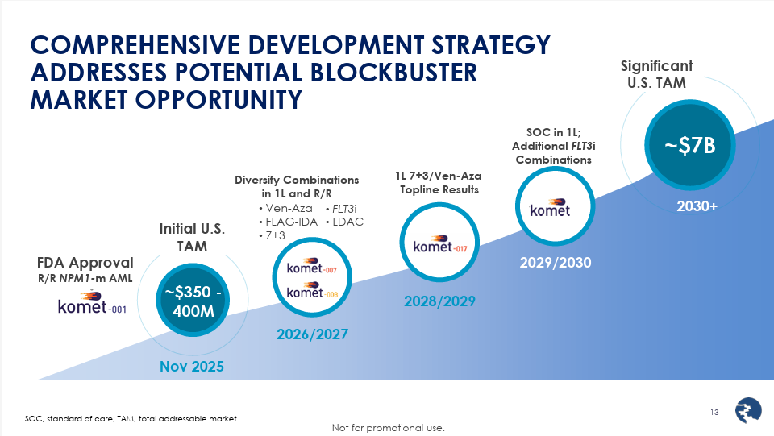
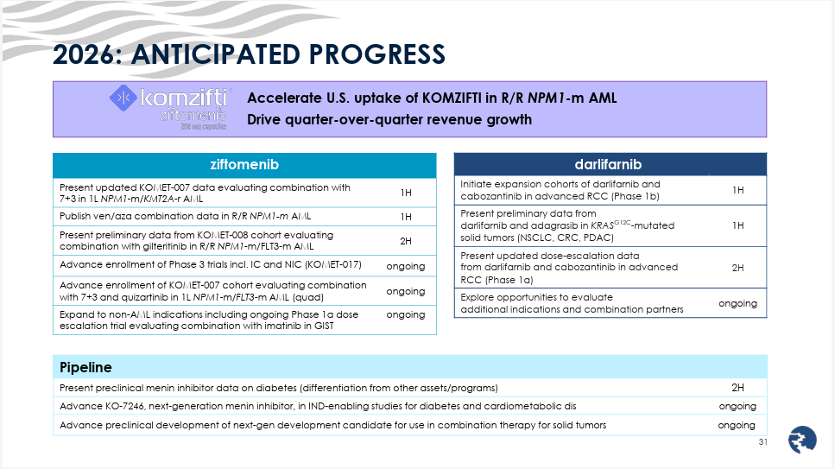

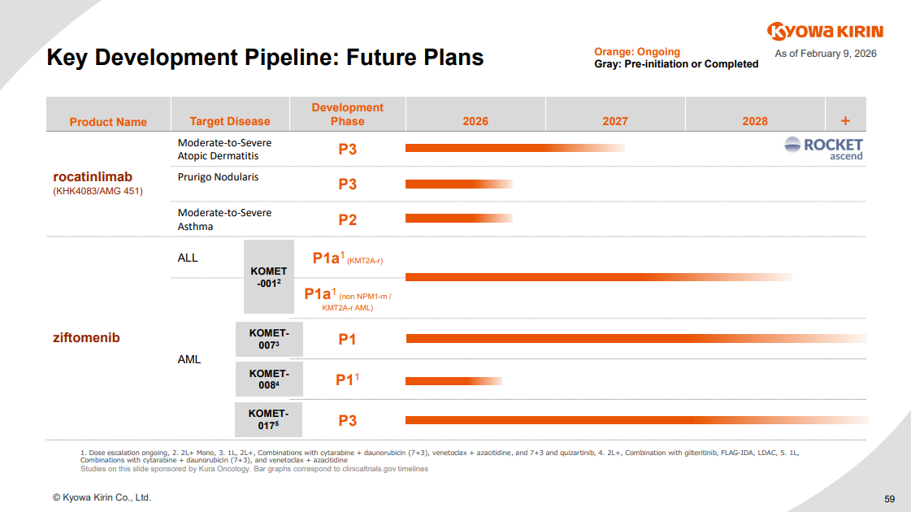

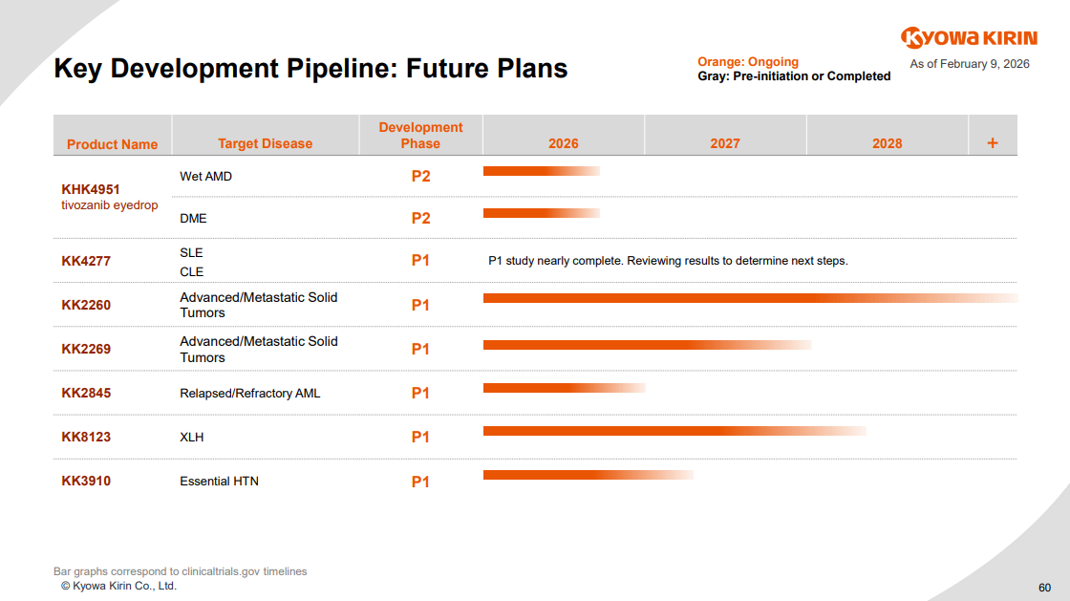

For questions, please reach out to:
International / Affiliates: Harjit Bajwa
US: Richa Sharma
Corporate Strategy, R&D and PCS: Claudia Lanauze Torres

Invite your colleagues to CI Edge | Manage Email Preferences | Unsubscribe

This document/email contains competitive intelligence collected via an approved competitive intelligence supplier working on behalf of AbbVie. We collect competitive intelligence consistent with industry standards and AbbVie policy. Not for field distribution. Please reach out to APEX/IMABI, Legal, or OEC teams wih any questions.

